Year 10 Introduction to Sculpture and Experimental Video:

This unit is to teach you pure aesthetics and harmonising principles of design
Plus, how well you’ve researched that. All ideas shown to teacher must show research behind it – how do I present it? how do I research it? What was I exploring in this work – what was it’s purpose (e.g. Dadaism exploration, questioning art – what is it? How does it reflect me)/

Soapstone Sculpture
Task: Create an abstract, natural form.

Draw the rock how you see it.
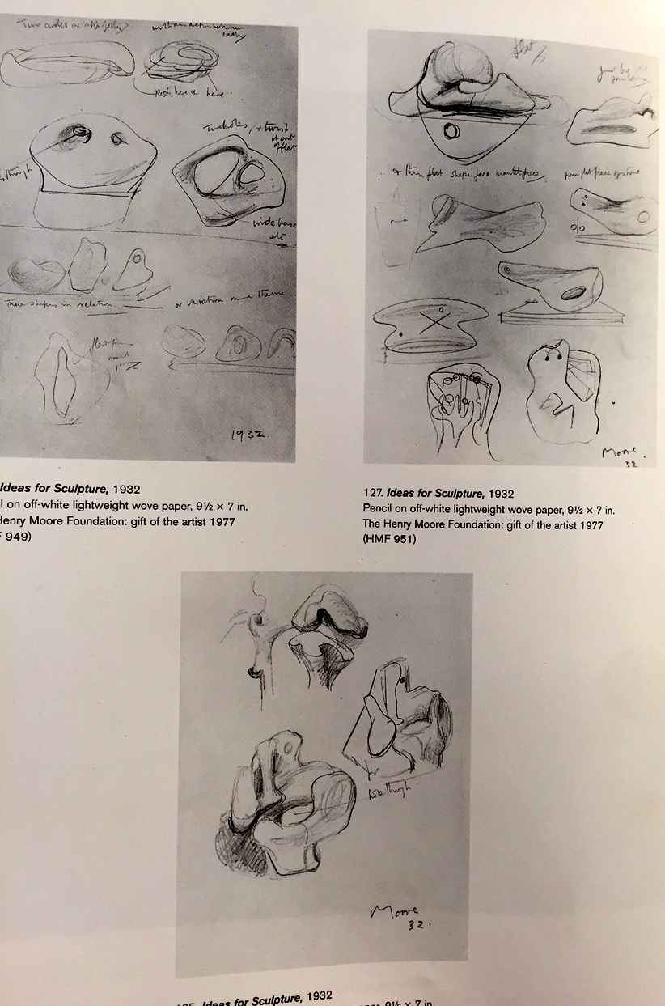
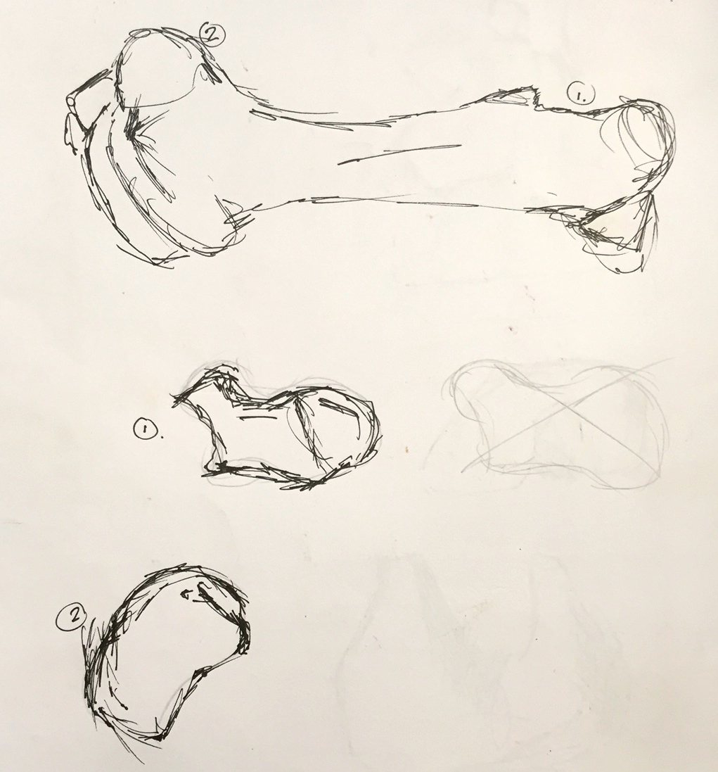
Explore how the rock naturally sits.
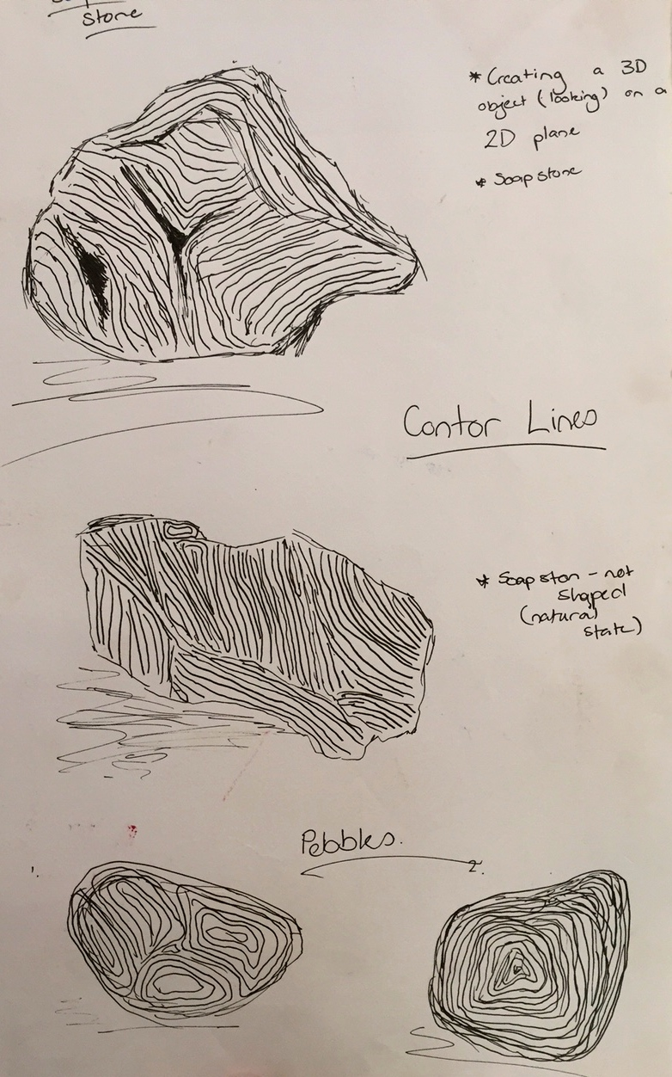

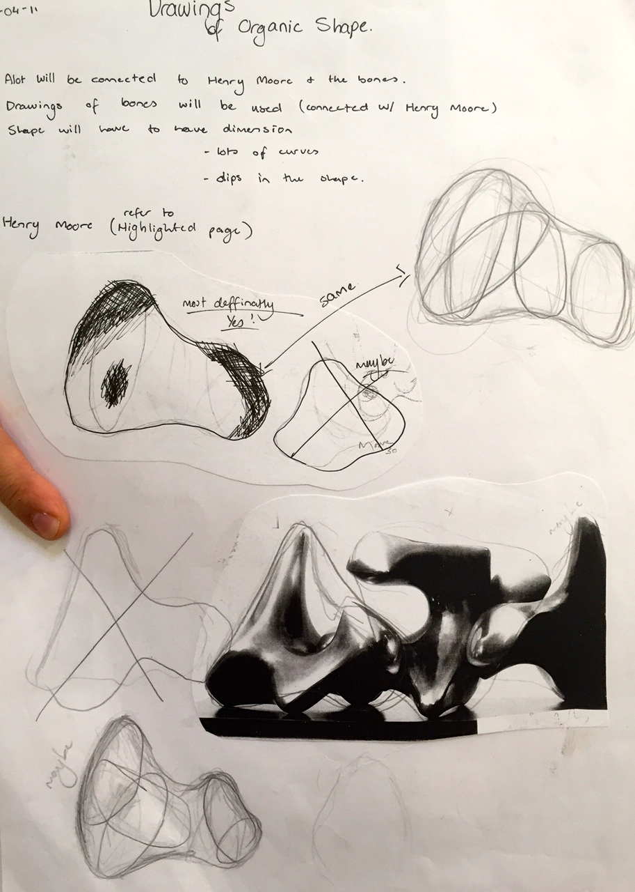
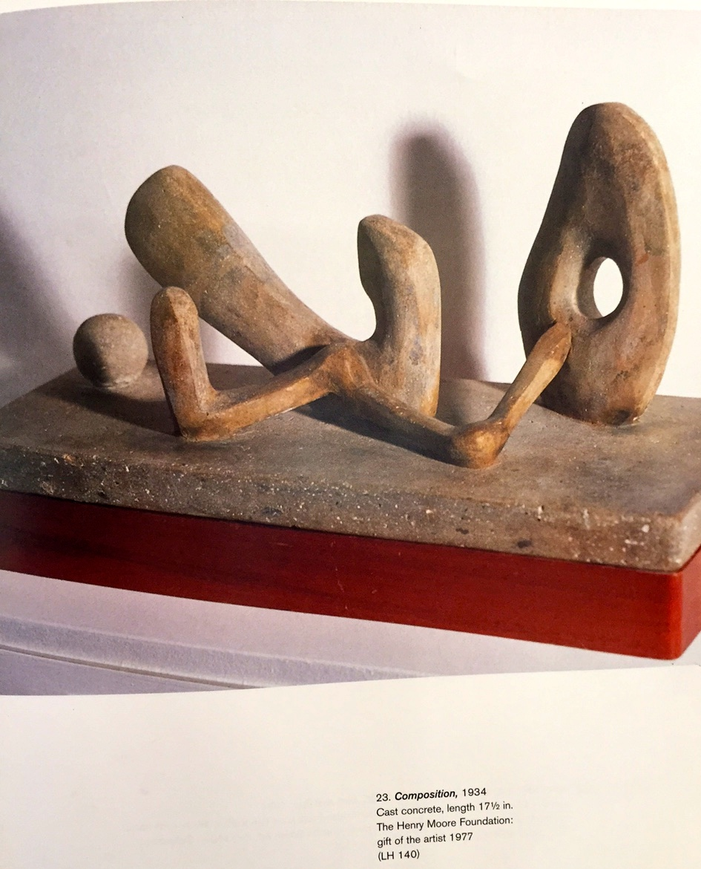
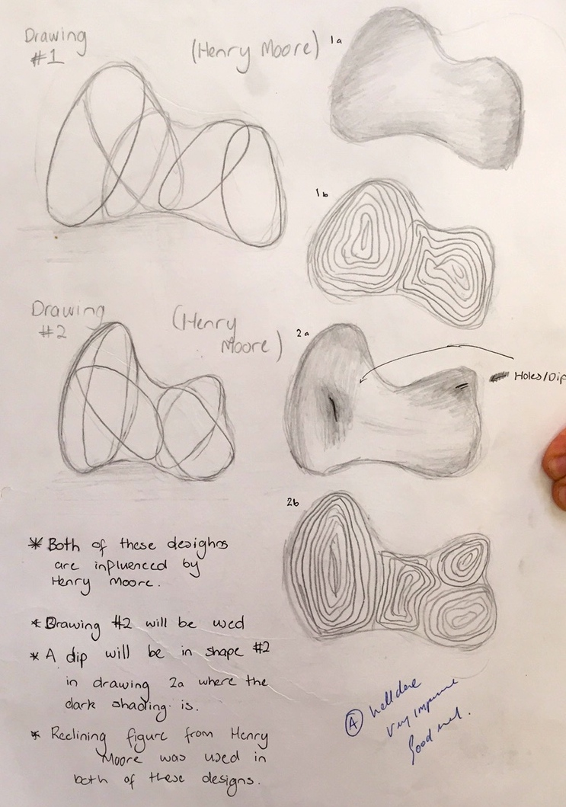

Do research first – be mindful of wastage as this is an expensive venture.

Research other artists who find the natural rock shape and work it further, like:

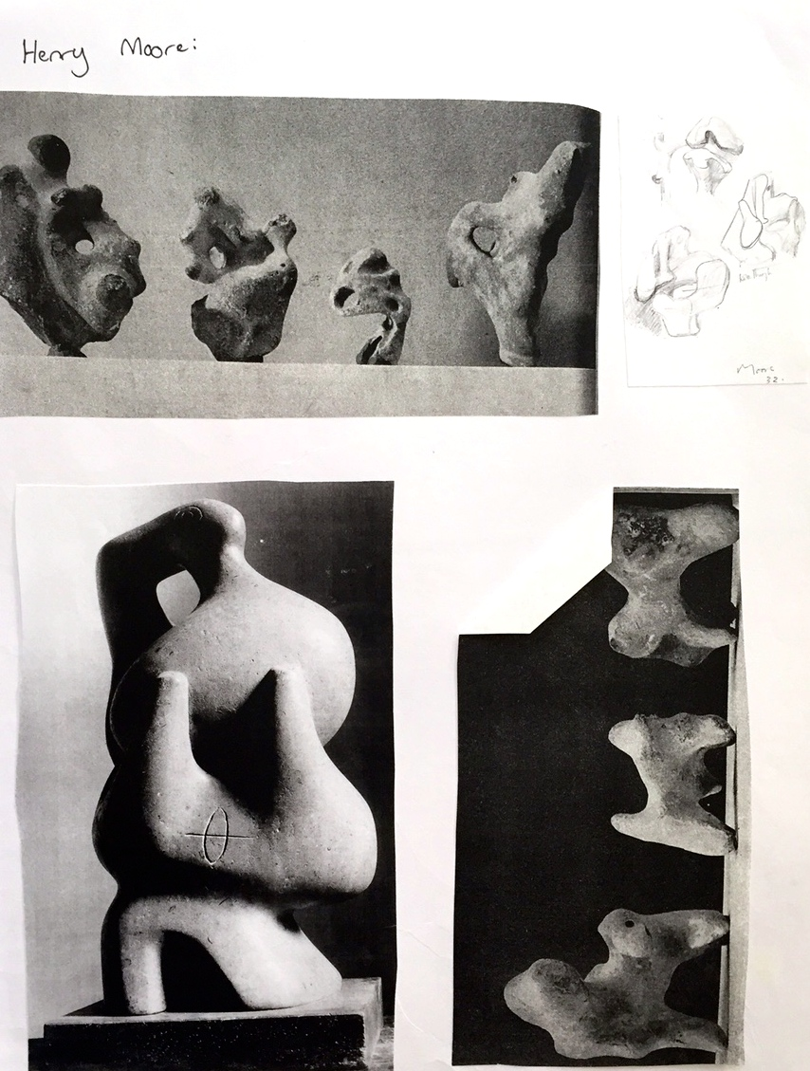
Henri Moore
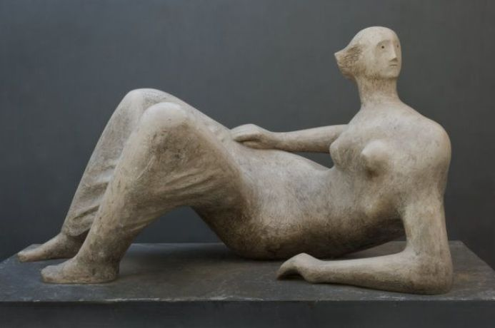

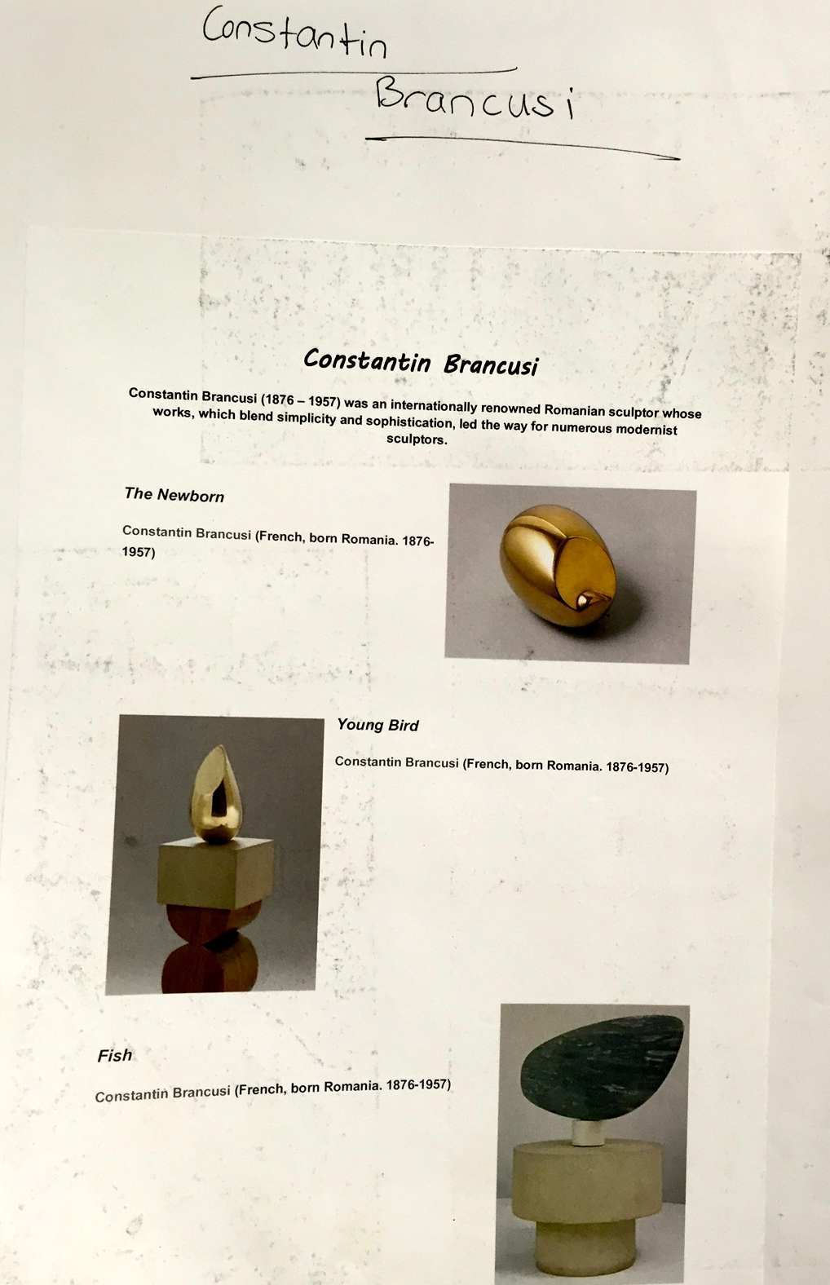
Constantin Brancusi
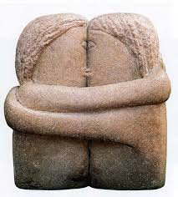

See how they find the natural shape:
Richard Deacon
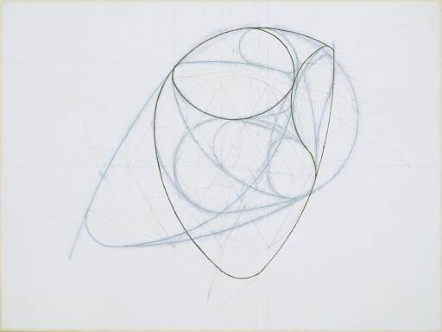

Limestone & jade are both similar stones – the key is to be in a natural shape not a pre-cut block as it makes it too difficult to find the natural shape inside.

Equipment needed:

- Apron and dust mask. We suggest Bunnings: White space medical suit (covers hair) or old clothes from home – plastic shower cap?
- Wet and dry sandpaper – if done thoroughly enough, lovely mirrored finish (no scratches/cuts)
- You’ll be spending more time on the heavier grades than the light.
- Always work wet with the stone – have water ready. Keep the used sandpaper and make more art (check out Suzanne Deneher)
- Towel also needed to wrap them and store them.
- Rasp tools – there are 7 or 8 in a pack
- Electric Dremel (Bunnings – about $40) (option of Air Dremel, but not as easy or fast)
- Needs constant cooling and cleaning out during the lesson or they’ll overheat and break.

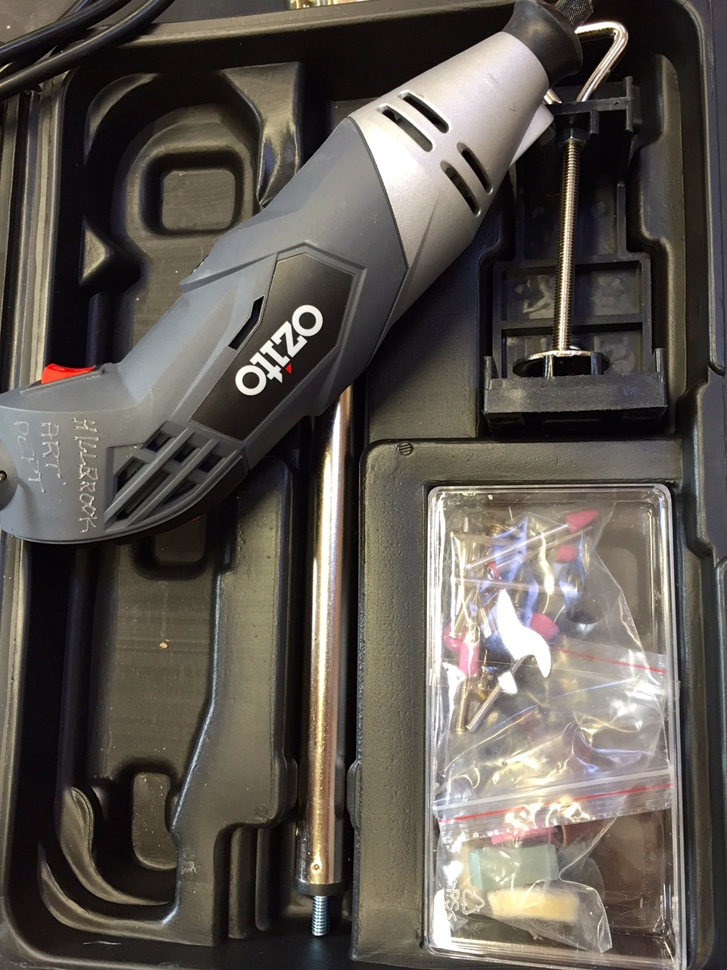
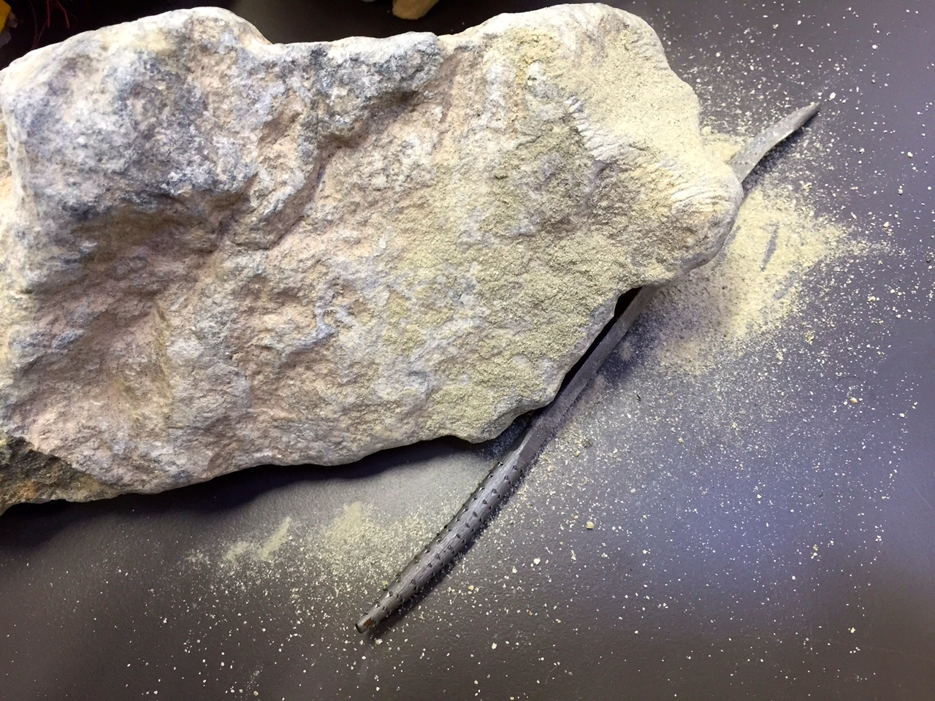
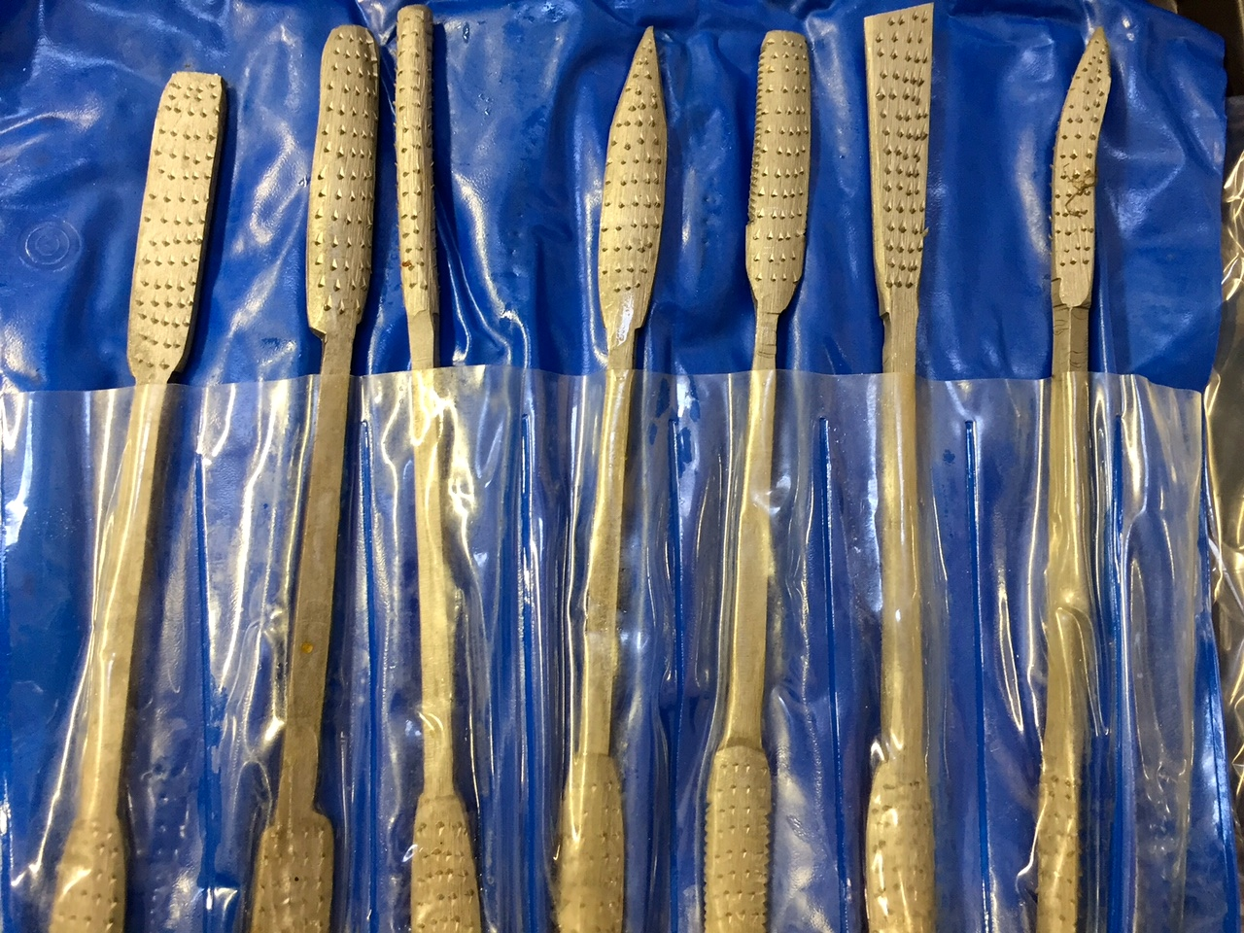

Ready made objects
Task: Manipulating a cup and saucer (see Meret Oppenheim)

- You will be given a cup and inside it will be a surprise material. That is the only material you may use, aside from glue and twine.
- Experiment with media – poke holes in it, glue it, weave it, stitch it together.
- Then take it one step further – handle, inside,
- It still must look like a cup at the end.

Before you begin:
Research other artists who use ready made objects.
Dadism (and surrealism) focus (anti-art/ mocking art/ appropriation)

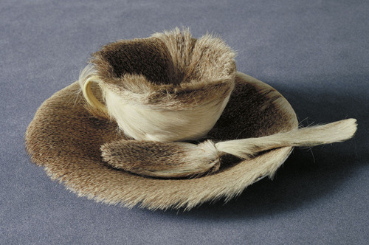

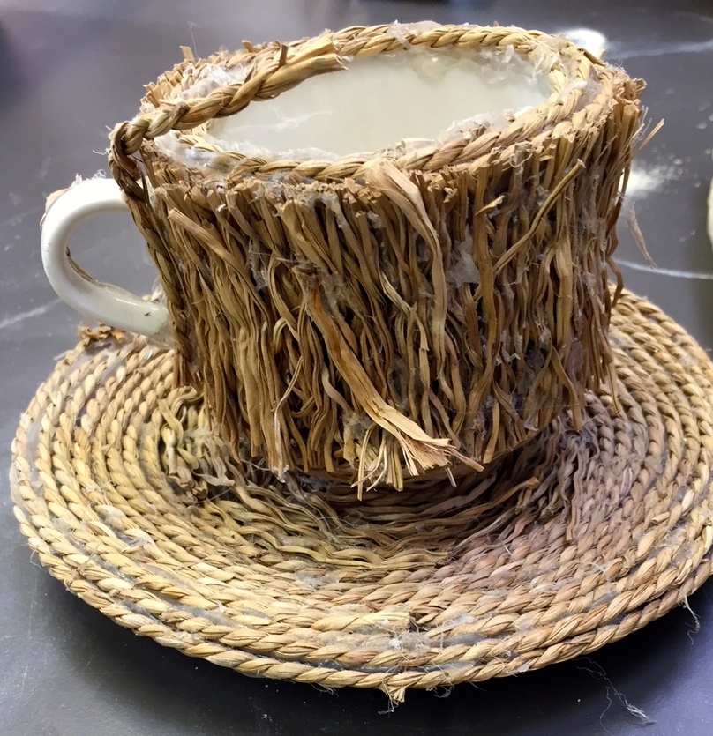
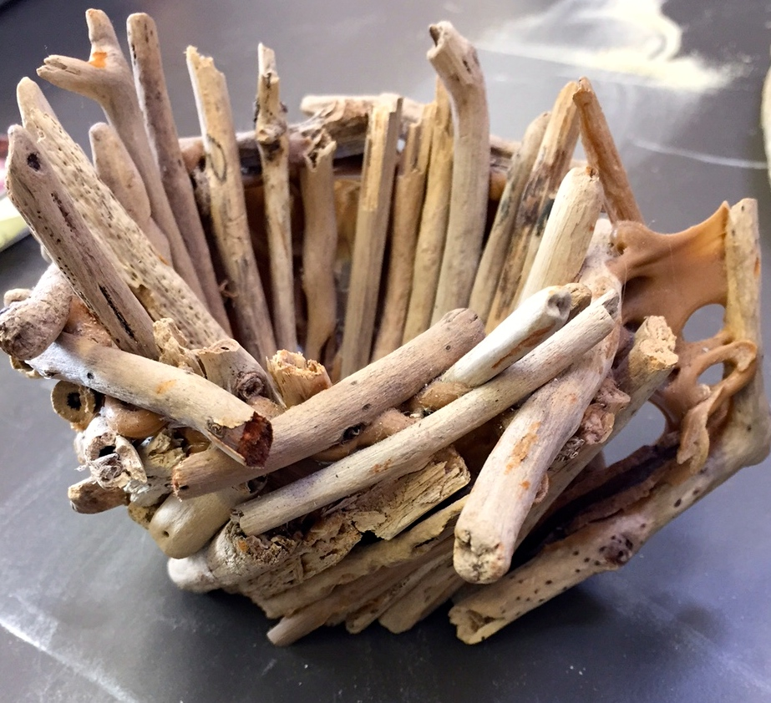
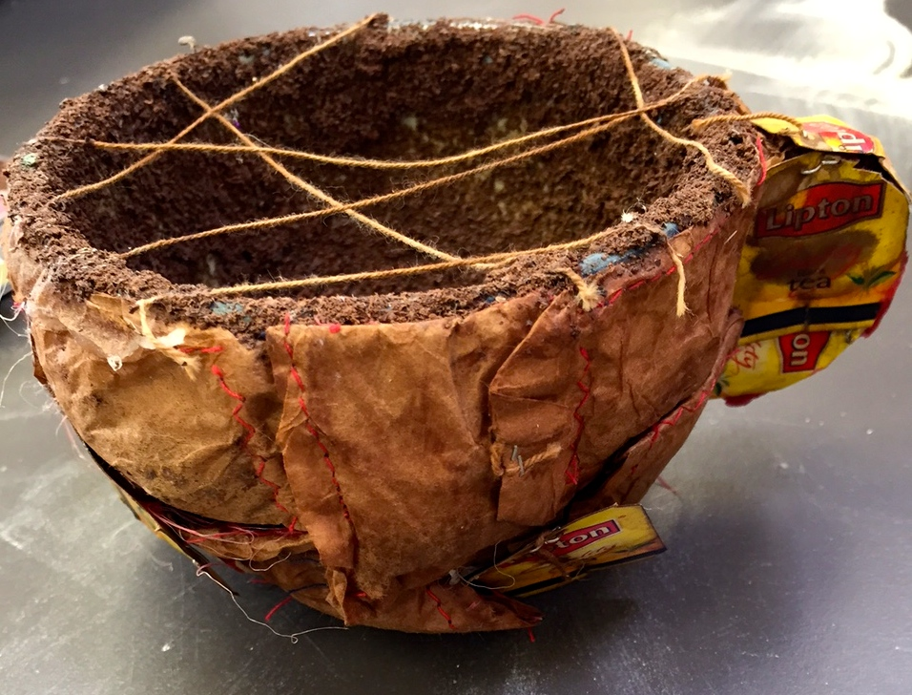
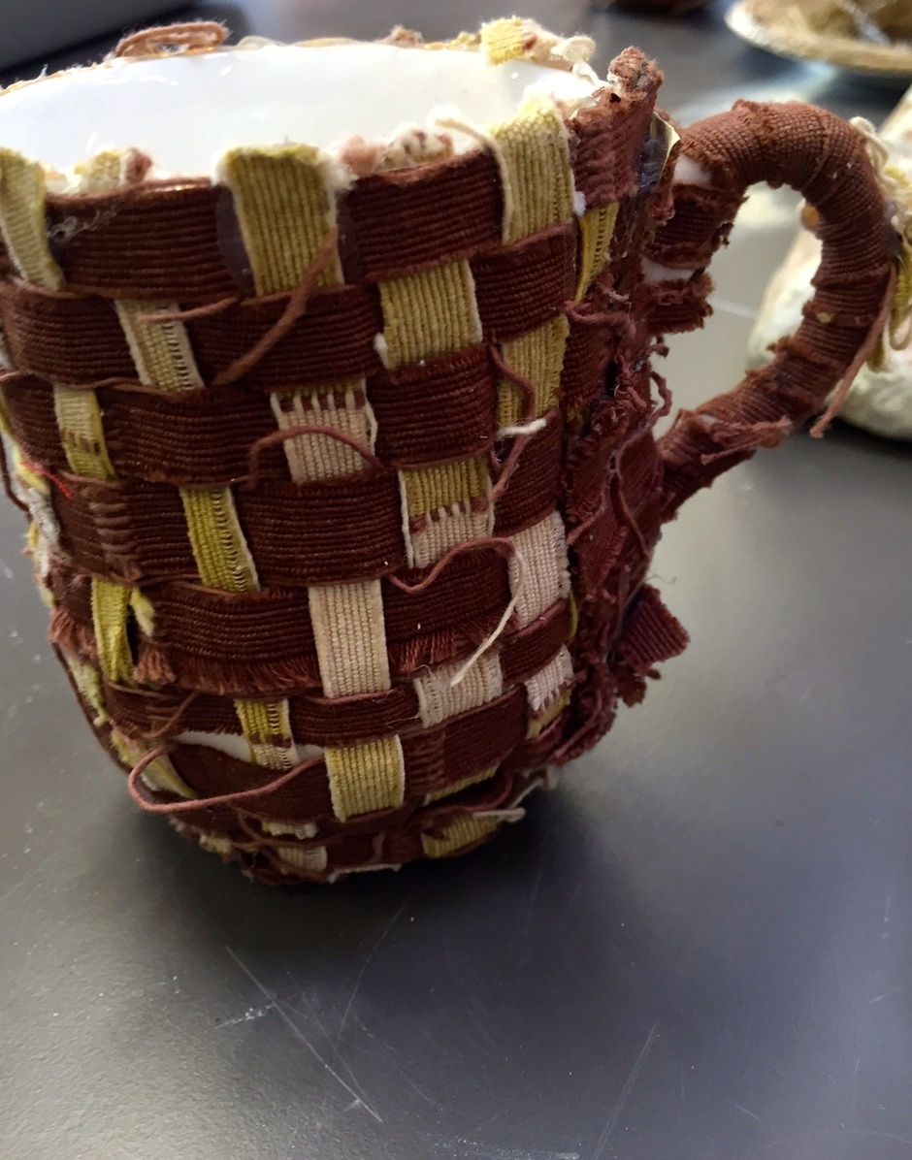

Jumpology (Philippe Halsman)
Task: Take 2 photos of yourself based on Jumpology
- First with a black/white backdrop (Drama stage or dark room entrance) (at school)
- Second on location. E.g. countryside – applicable clothing (in your own time)

Research examples of Jumpology.

Rules:
- Centre yourself in the shot. Multiple shot & timer setting on your phone. Take photo of yourself. Take a series of them. Must be in focus. School uniform. Make black & white Give images to teachers to crop.
- Focus is to be ‘out of control’
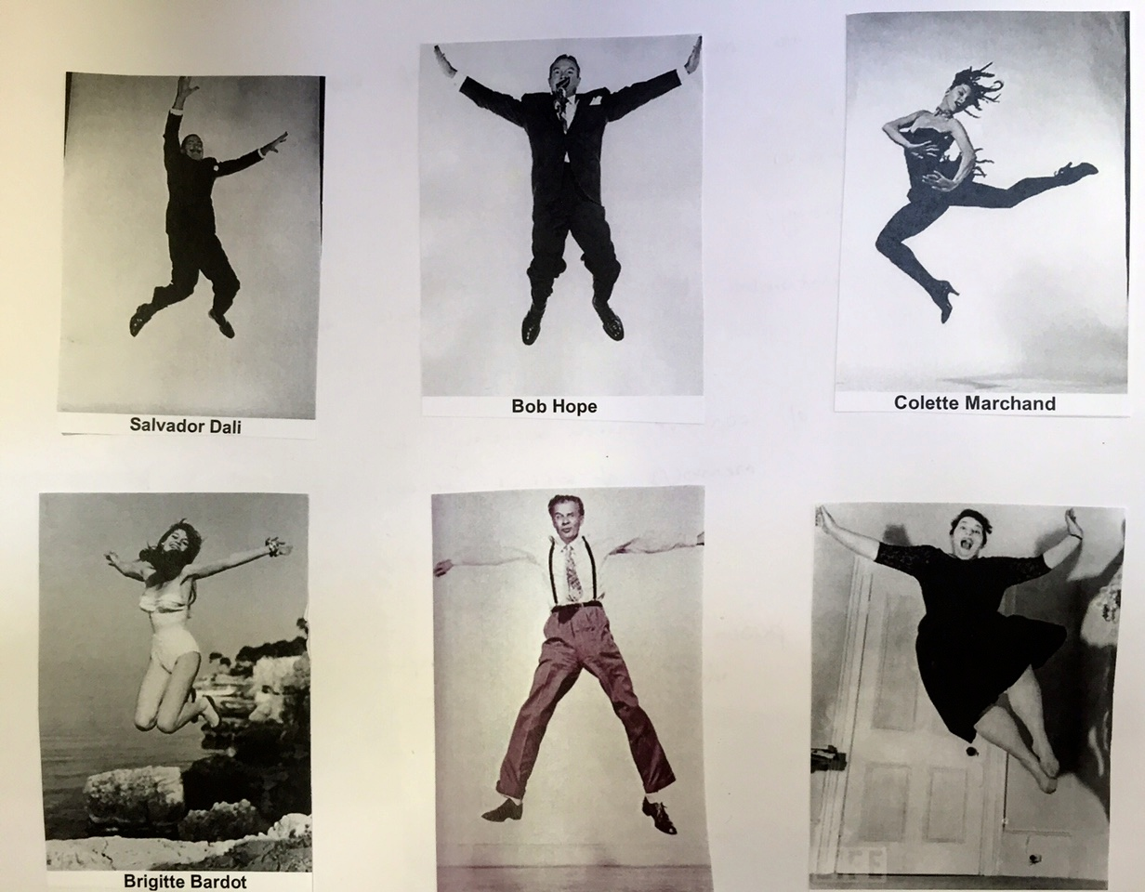
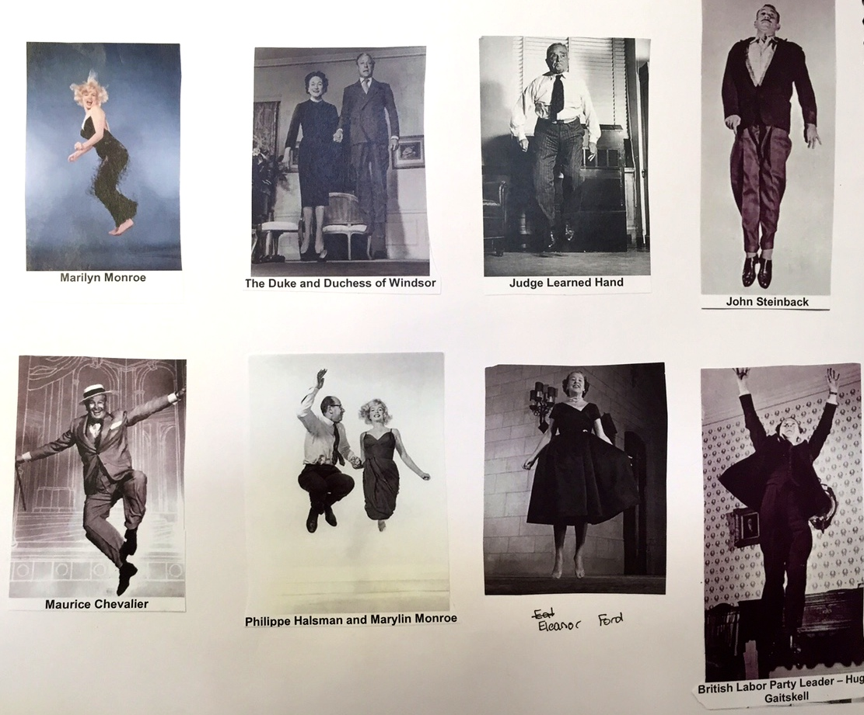
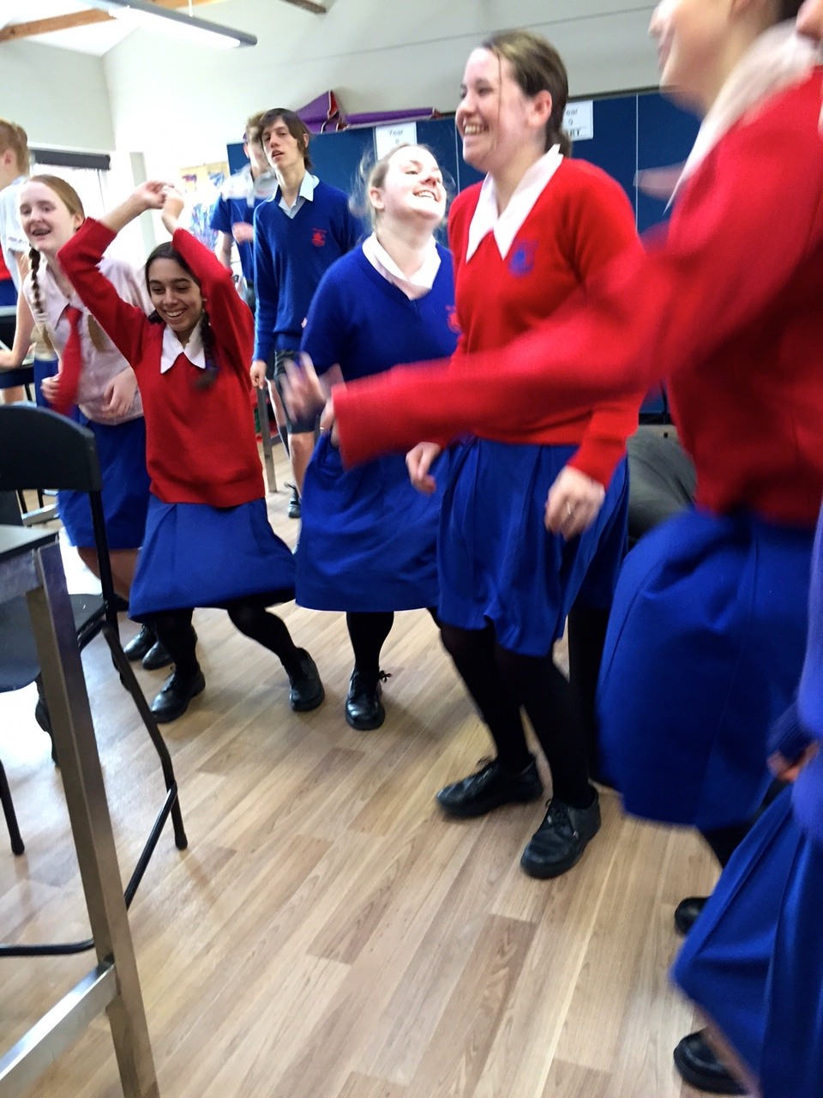

Dadaist videos

Task: Make 2 x two minute videos in the style of Sean Gladwell

- Come up with your own 2 minute amateur film of an interest or hobby. Dub non-lyric music into one of them and sound complements the action you’re doing. Using this same piece then…
- Consider how innovative you can be in the way you film yourself (e.g. stick on end of stick looking down at me? Stick on my shoe so it’s dynamic?). Also consider your safety. Make the audio a juxtaposition piece – something completely opposite what is expected.

Inspiration: Sean Gladwell
Sydney based artist making home videos on his phone – travels the world. Then adds music.
He does a lot of work of illusion of space and repetition. Also explores his interest and hobbies.

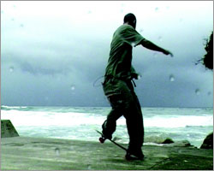

What is ‘Art’?

- First responses should be challenged rationally
- Work in pairs to research potential meanings
- Share outcomes with group
- Save this meaning in your visual diary in Year 10, 11 & 12, building on it and refining it until you are sure you understand its meaning.

